Assignment 9

***Video Demo Below
https://drive.google.com/file/d/1GtRULrM4_D5Lp0WFX79dxKWGs-pPW2HO/view?usp=sharing

***Screen shots below

Main menu

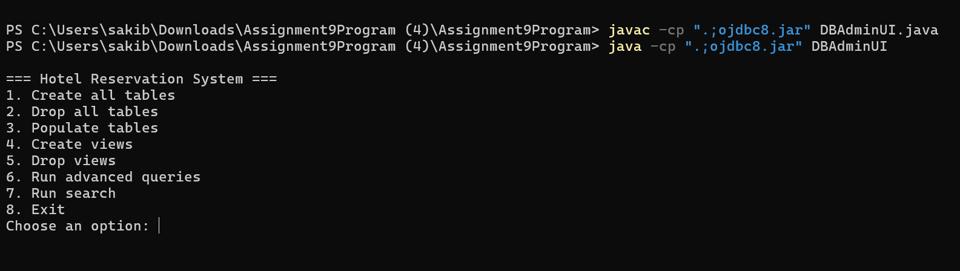

Create All Tables
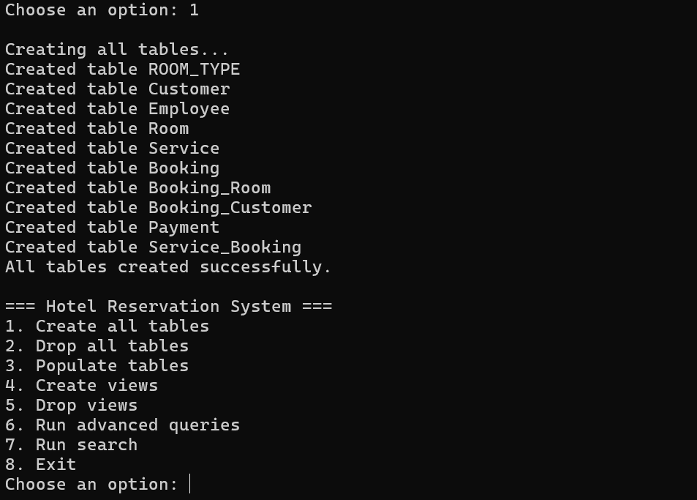

Create Views
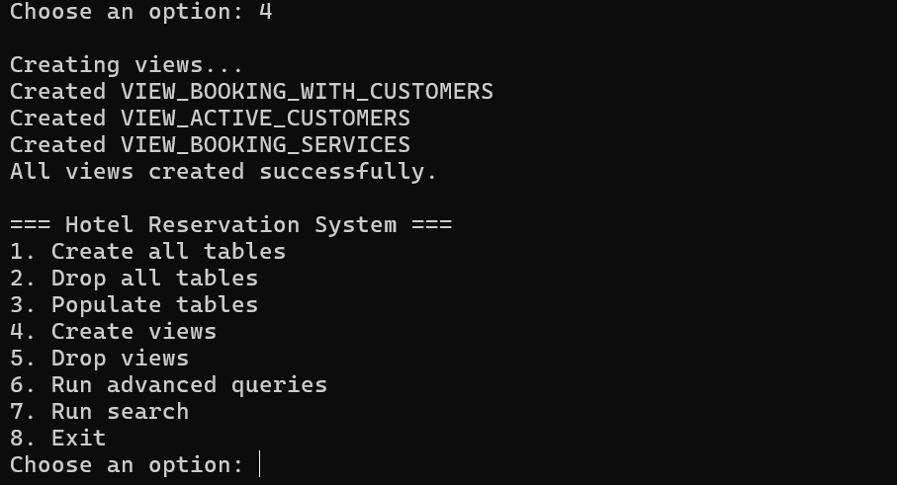

Populate Tables
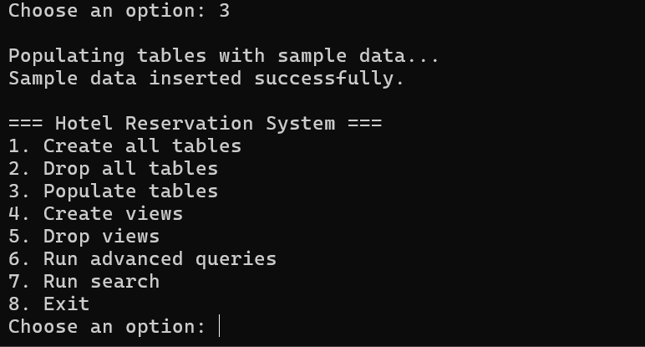

Advanced Queries (AQ) Menu
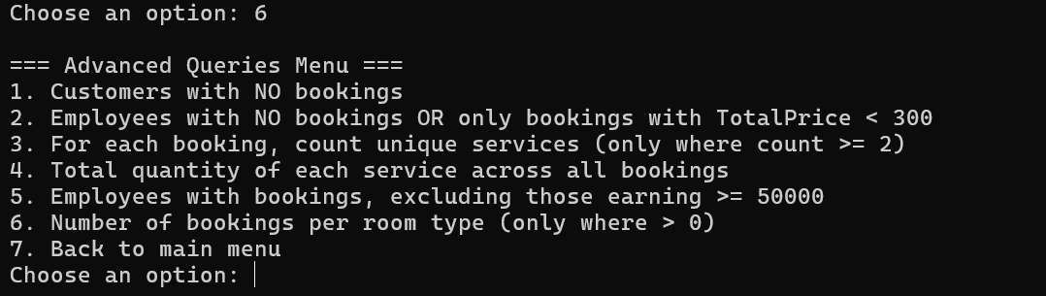

AQ1
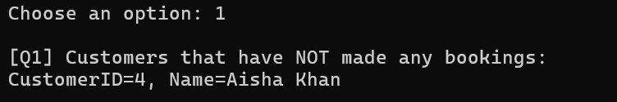

AQ2
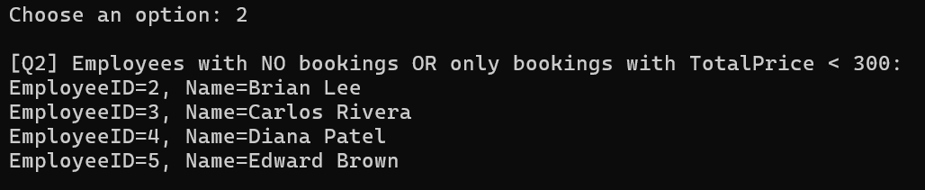

AQ3
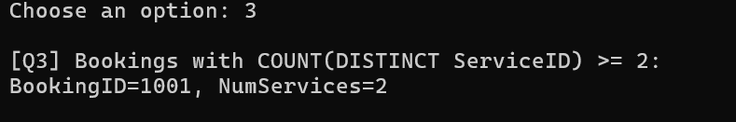

AQ4
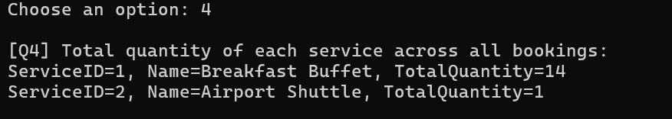

AQ5
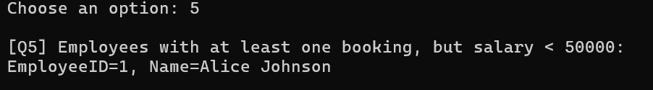

AQ6
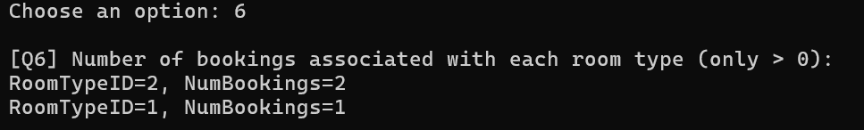

Specific Record Search

Search Menu
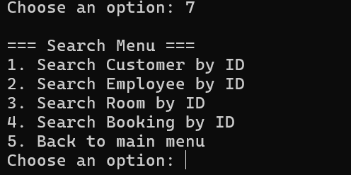

Customer Search
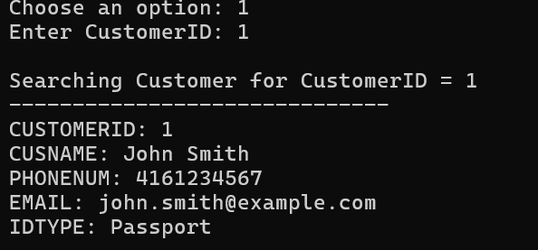

Employee Search
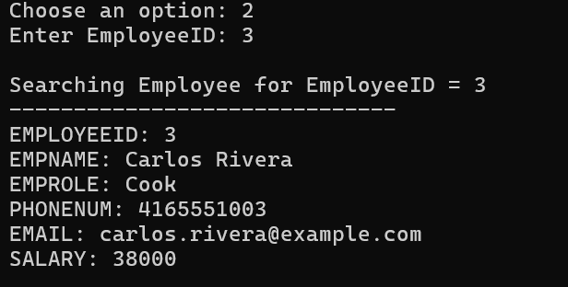

Room Search
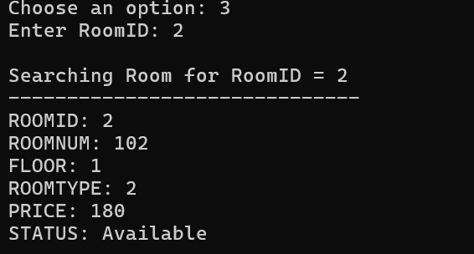

Booking Search

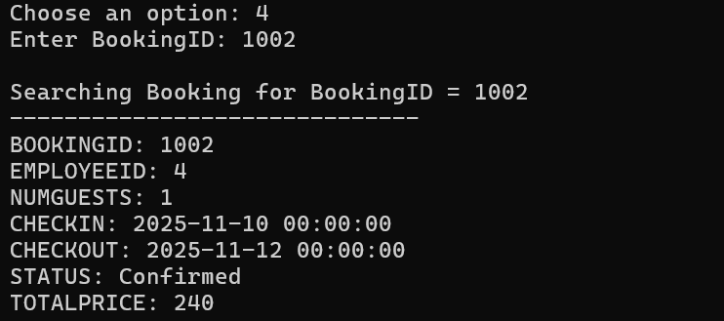

Drop All Views
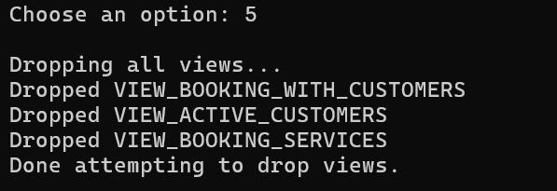

Drop All Tables
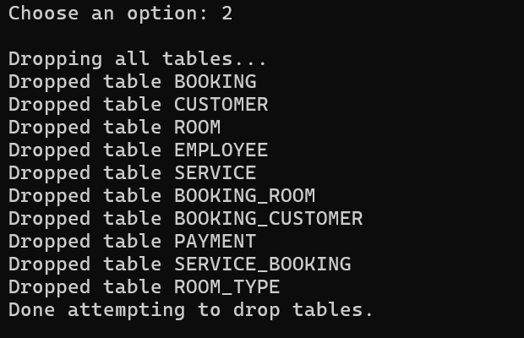

Exit

